Detailed Notes: Configuring GitHub Data Source Collector for IBM API Connect

1. Introduction
This guide explains step-by-step how to configure a GitHub data source collector to be used with IBM API Connect. By the end of this guide, you will be able to connect your GitHub repository as a data source, so that APIs stored in your repo can be discovered, copied to drafts, and managed through the API lifecycle in IBM API Connect.

2. Accessing IBM API Connect API Manager
a. Open the Console
- Visit the IBM API Connect SaaS console: console.sass.ibm.com
- Log in using your credentials (username and password).
b. Select and Launch Instance
- After login, the API Connect instances will be displayed.
- Select your desired instance (e.g., API-connect-os, running on AWS).
- Click to launch the instance.

3. Exploring the API Manager Interface
a. Organization Structure
- Go to Settings to view your organization's name.
- The default organization name is created during instance initialization (e.g., API-connect-zero).
- This organization name can be changed as required.
b. Discover Tab
- Click Discover to view two tabs: APIs and Sources.
  - Sources: Where your APIs are coming from (e.g., GitHub).
  - APIs: Displays APIs discovered from sources.
- You need to "copy" APIs to Drafts to manage their lifecycle (develop, deploy, publish).
- 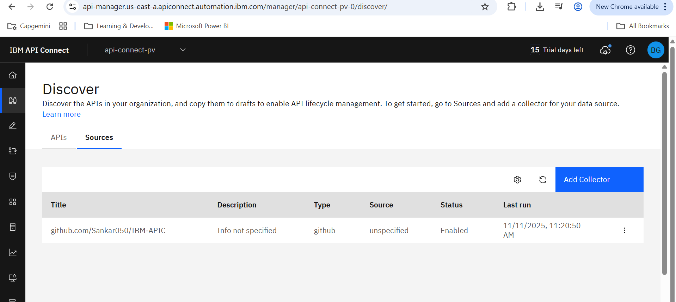

4. Configuring the GitHub Data Source Collector
a. Starting the Data Source Collector Setup
- Go to Sources > Add Collector.
- We can’t directly add the data source collect. First, we have to setup the GitHub so it can automatically add it into data source collectors
- Information required for configuration:
  - Host (API Connect instance URL)
  - Provider Organization
  - API Key (must be created, will cover this later)
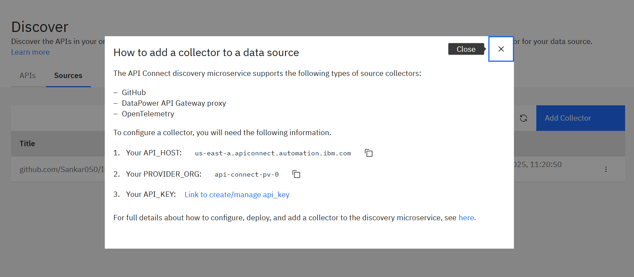

5. Preparing the GitHub Repository
a. Required Structure
- In your GitHub repo, create a folder: .github/workflows/
- Inside this folder, create a workflow YAML file (e.g., discover-api.yml).
b. IBM-Provided Workflow Template
- Use the template/workflow action file provided by IBM.
- https://github.com/ibm-apiconnect/apic-discovery-test - we use this for sample implementation
- Key items in the workflow YAML:
  - API Host (from your API Connect instance)
  - Provider Organization (from your API Connect)
  - Platform API (usually kept as default)
  - API Key (to be stored as a GitHub secret)
  - API Files Path (location of OpenAPI/Swagger files in your repo)
  - Insecure Skip TLS Verify (set as true to skip certificate validation, usually for demo/dev)
Example of Important Environment Variables in the Workflow
- env:
- API_HOST: us-east-a.apiconnect.automation.ibm.com
- # platform_api_prefix is not required to change for ApiConnect on Cloud
- PLATFORM_API_PREFIX: platform-api
- PROVIDER_ORG: api-connect-pv-0
- INSECURE_SKIP_TLS_VERIFY: True
- API_FILES: APIfolder/api-with-examples.yaml
- #API_FOLDERS: APIfolder,APIfolderTwo
- API_KEY should NOT be hardcoded. It is referenced as a GitHub secret.
c. Referencing Example Repositories
- IBM provides sample repos:
  - API-discovery-action: https://github.com/IBM/api-discovery-action
  - API-discovery-test: https://github.com/IBM/api-discovery-test
d. Using the Example Repo
- Download the sample repo (excluding README if not required). - https://github.com/IBM/api-discovery-test
- Copy the .github/workflows directory and any api/ folder with sample API definition files into your own repo.
- Remove any unnecessary extra workflow files, keeping just the required workflow files. (C:\Users\bhguntak\Desktop\IBM-APIC\.github\workflows)
- Adjust the Workflow YAML with your unique environment variables (host, organization, etc).
- 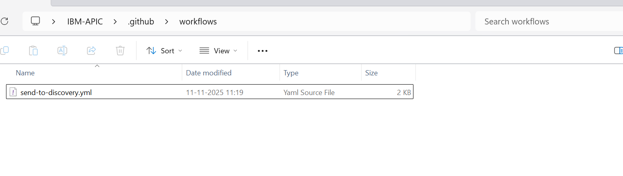

6. Configuring the Discovery Workflow YAML
- Open the workflow YAML file (discover-api.yml or similar).
- Update the following:
  - API Host: Copy from your API Connect instance.
  - Provider Organization: Get from your API Connect instance.
  - Platform API: Usually keep as-is.
  - Insecure Skip TLS Verify: Set to true if you do not want certificate validation.
  - API_FILES: Path to your API specs (e.g., api/ or api-with-examples/).
- Ensure secrets such as API_KEY are not hardcoded, but referenced via GitHub secrets.

7. Creating the API Key in API Connect
a. Steps to Create an API Key
- In API Manager, click Profile (your user profile).
- Navigate to My API Keys.
- Click Add to create a new API key.
  - Give the key a name (e.g., DataSource1).
  - Set the timeout (e.g., 5 hours).
  - Enable Multiple Use if needed.
  - Click Create.
- Copy the API key value. You may view or delete/manage keys from this section.

8. Adding the API Key as a GitHub Secret
a. Configure Repository Secret
- Go to your GitHub repository Settings > Secrets and variables > Actions.
- Click New repository secret.
- Name: apicApikey (this key name based on variable created in yaml file.)
- Value: Paste the API key copied from API Connect.
- Save the secret.

9. Finalizing and Testing Integration
a. Pushing the Changes
- Ensure your local repo structure includes the copied workflow and API folders.
- Stage and commit your changes in Git:
git add .
git commit -m "Add GitHub data source configuration for IBM API Connect"
git push
- Push the changes to GitHub.
b. Trigger the Workflow
- After pushing, go to the Actions tab in your GitHub repo.
- The discovery workflow will start automatically.
- Check the logs:
  - Look for entries indicating the workflow ran successfully (e.g., HTTP status code 201 for successful operations).
  - Warnings about certificate validation may appear if skipping TLS verification.

10. Verifying in API Connect
a. View the Data Source Collector
- In API Manager, go to Discover > Sources.
- You should now see your GitHub data source collector added (with type: GitHub and your repo mentioned).
b. Check Discovered APIs
- Go to the APIs tab within Discover.
- Your sample API (from the API folder in your repo) should be listed.
- Details like API name, description, and available paths (e.g., / and /v2) are visible.
c. Copy API to Drafts
- Select the discovered API and choose Copy to draft.
- This makes the API available in the Drafts section for further development, deployment, or publication as part of API lifecycle management.
d. Metadata and Source Inspection
- You can inspect metadata and the source from which the API was obtained.

11. Summary
- Purpose: Connect GitHub repo as a data source collector for API discovery in IBM API Connect.
- Key Steps:
  - Prepare API Connect instance and gather necessary info (host, org, API key).
  - Set up .github/workflows/ in your GitHub repo with an IBM-provided workflow YAML.
  - Add your APIs (OpenAPI/Swagger) in the specified folder.
  - Create and store a secret API key in GitHub.
  - Push changes, let workflow execute, and confirm collection in API Connect.
  - Copy discovered APIs to Drafts for further API lifecycle actions.

12. Tips and Troubleshooting
- Workflow Not Showing? Ensure your workflow YAML file is in .github/workflows/.
- API Key Issues? Double-check API key in both API Connect and GitHub secrets.
- Certificate Warnings? If using in prod, set INSECURE_SKIP_TLS_VERIFY to false and provide valid certificates.
- Discovered API Not Appearing? Refresh in API Connect or check workflow logs for errors.

Resources
- IBM API Connect Docs
- IBM Sample Repos: API-discovery-action and API-discovery-test
- GitHub Actions Documentation

